P369 to Lens

1. View Scene

1.1 Scroll the mouse wheel
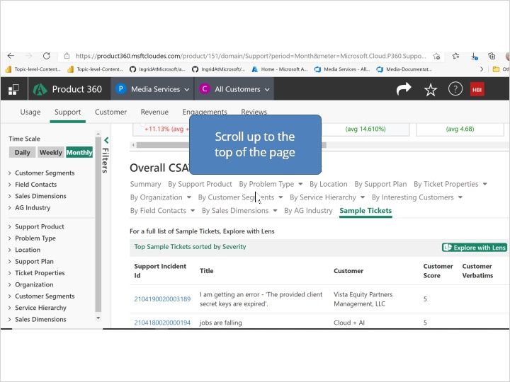

1.2 Click the Products menu button
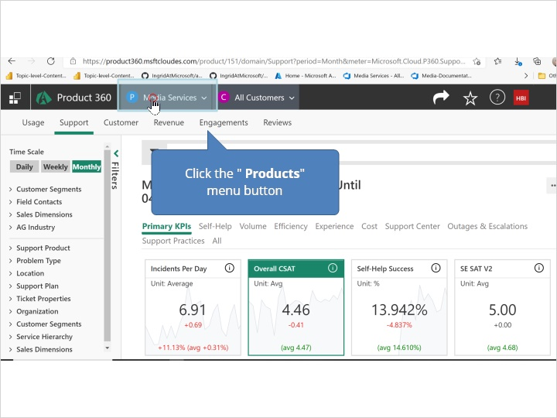

1.3 Type Media
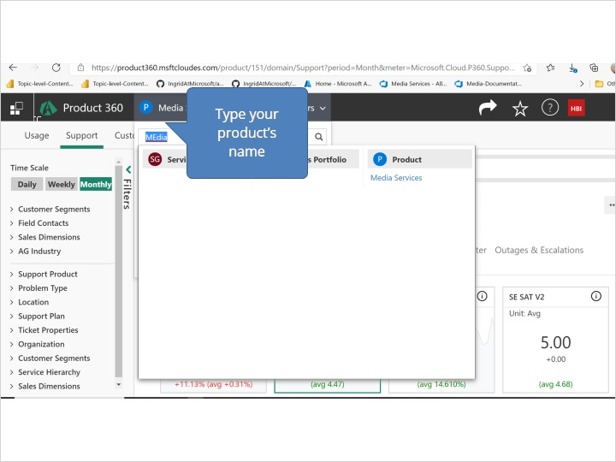

1.4 Click the group
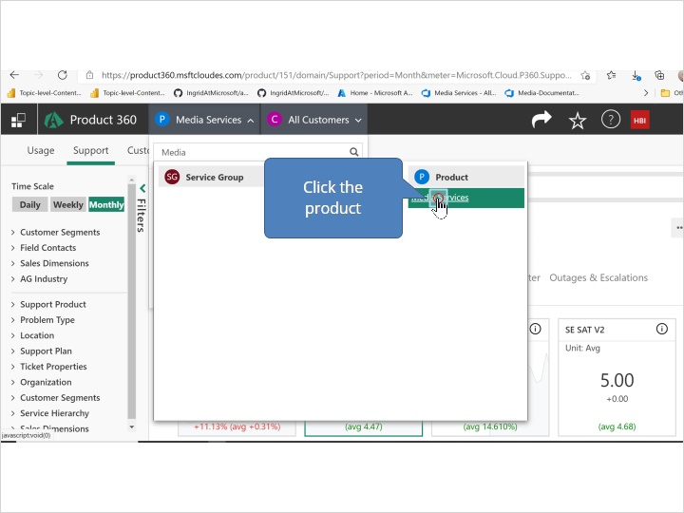

1.5 Click the group
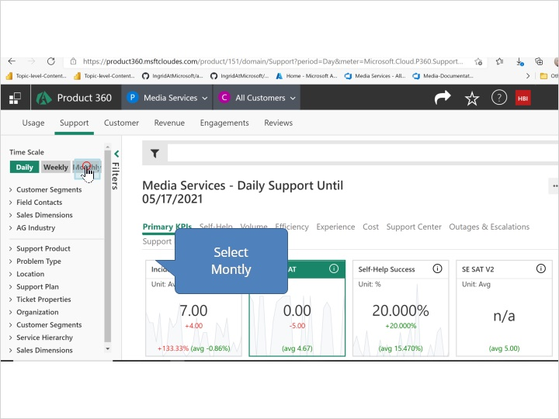

1.6 Click the Self-Help label
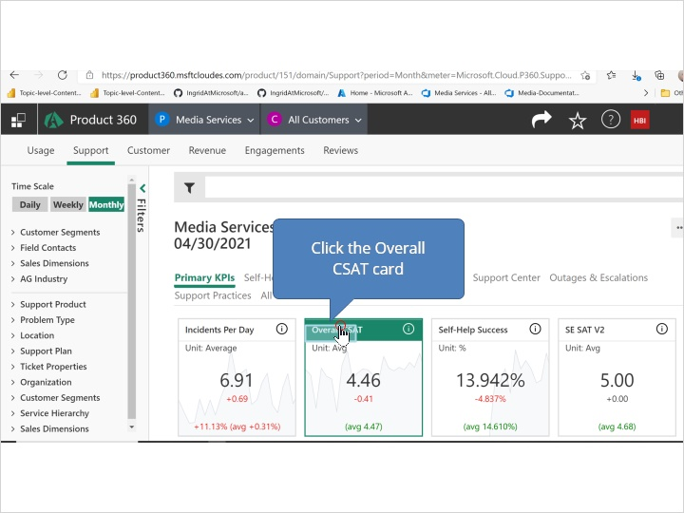

1.7 Scroll the mouse wheel
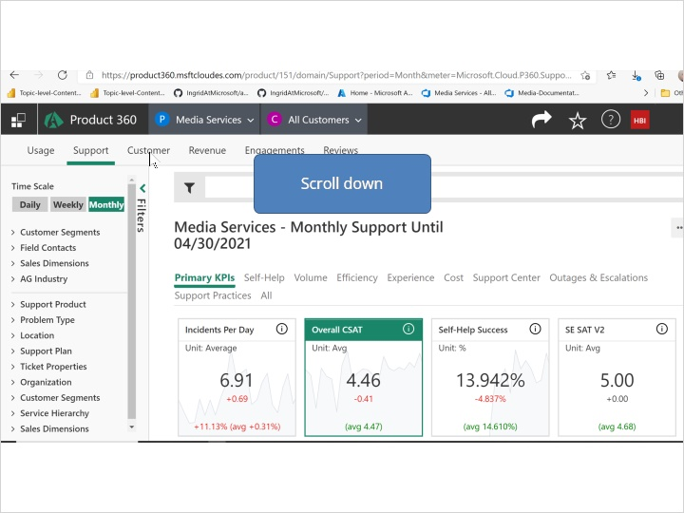

1.8 Click the Overall CSAT (Avg) - Monthly Support pane
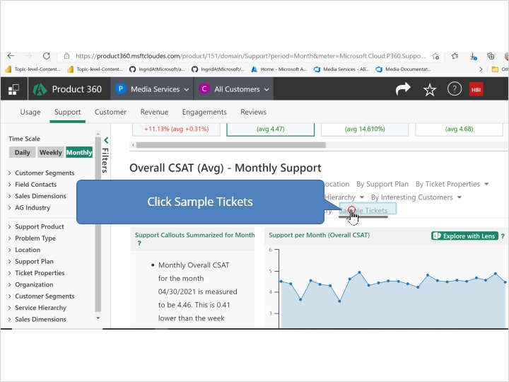

1.9 Click the Sample Tickets tab page
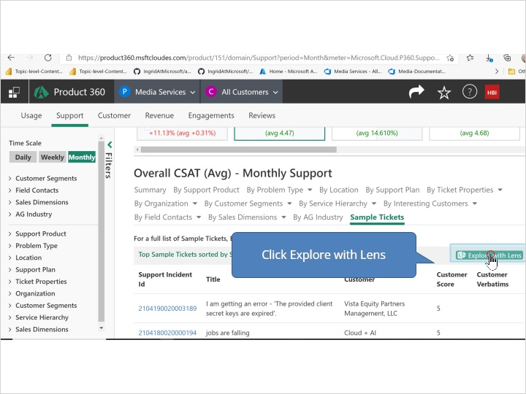

2. Try Scene

2.1 Now you try


2.2 Click the Products menu button
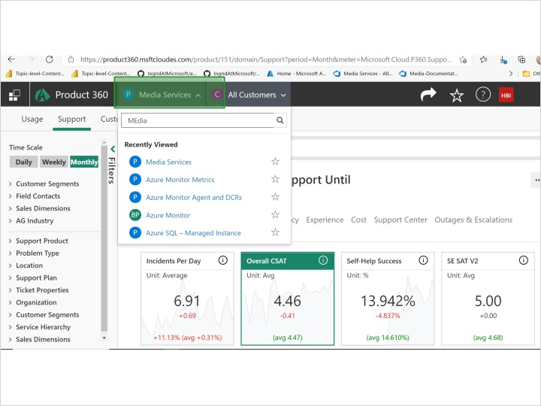
Notes:

Rectangular Hotspot 1 (Slide Layer)
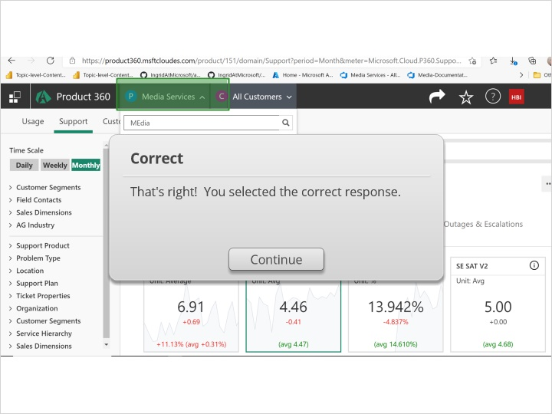

Try Again (Slide Layer)
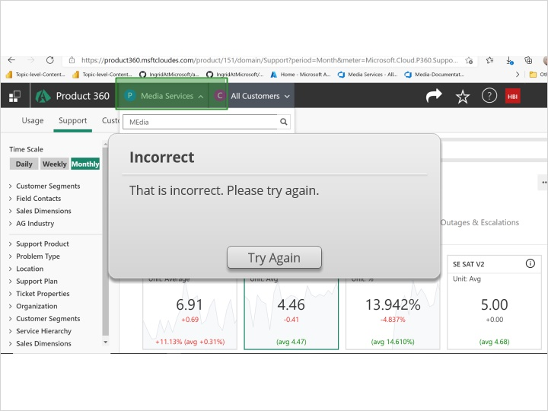

Hint Caption (Slide Layer)
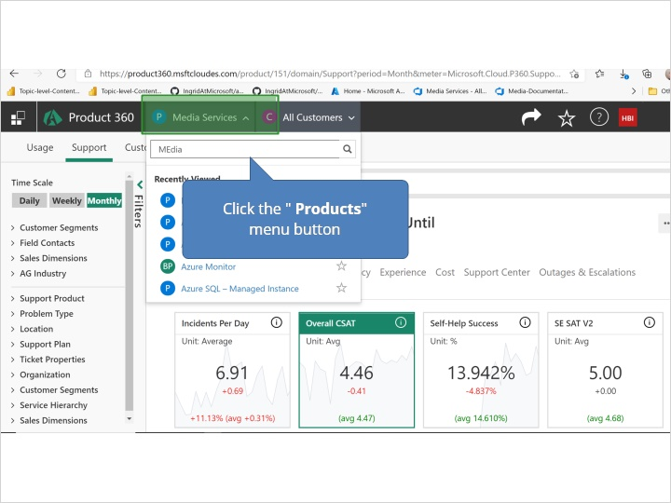

2.3 Type Media
(Text Entry, 10 points, unlimited attempts permitted)
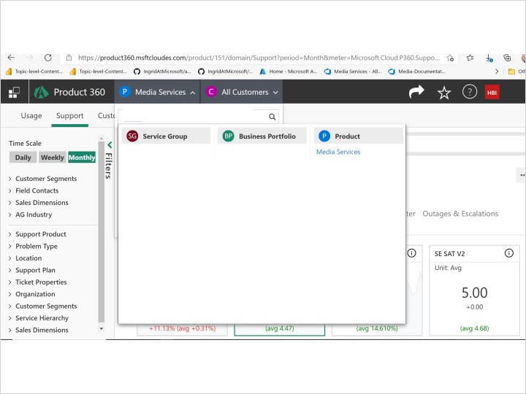

Feedback when incorrect:
You did not select the correct response.

Incorrect (Slide Layer)
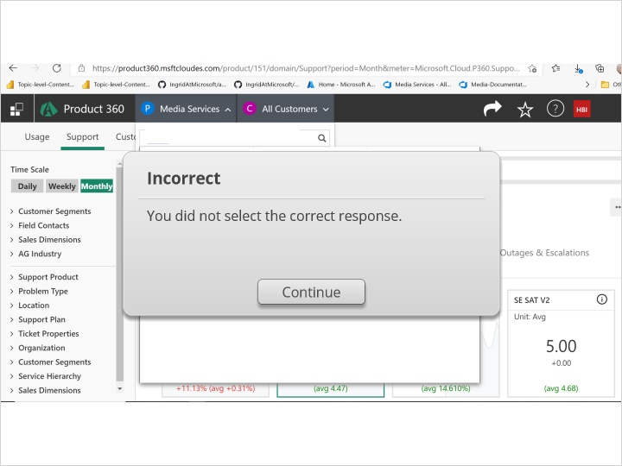

Try Again (Slide Layer)
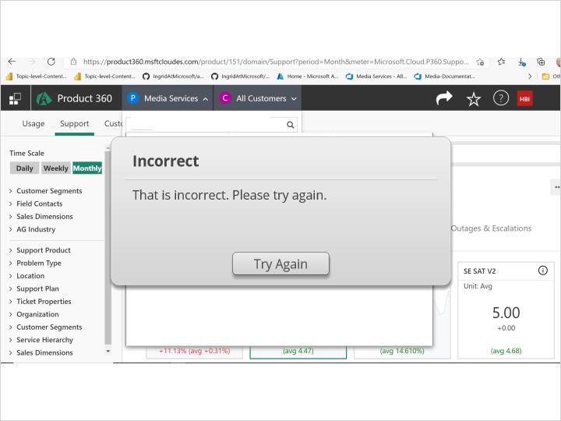

Hint Caption (Slide Layer)
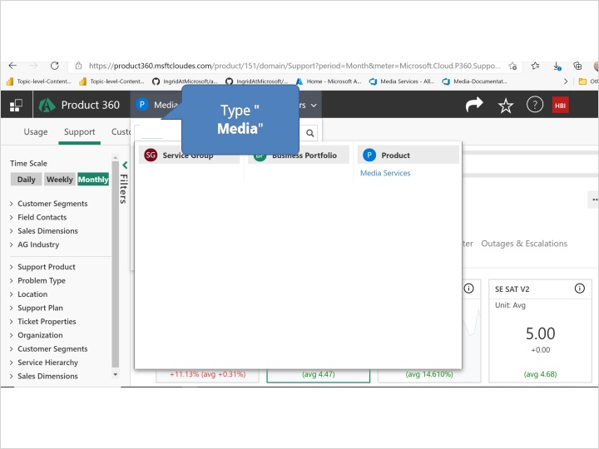

2.4 Click the group
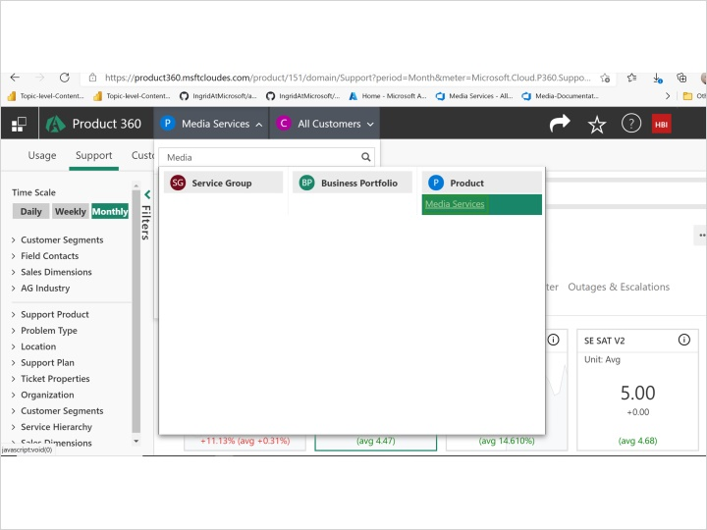

Rectangular Hotspot 1 (Slide Layer)
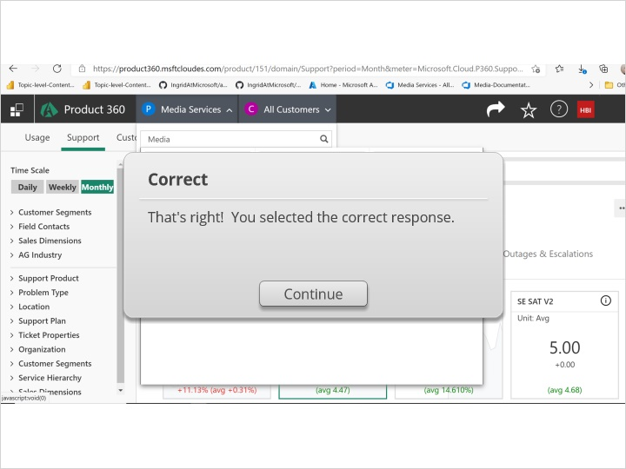

Try Again (Slide Layer)
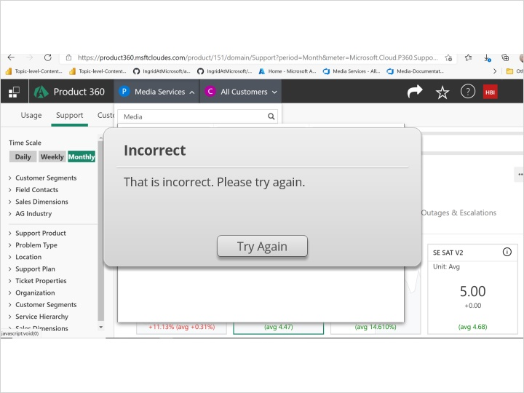

Hint Caption (Slide Layer)
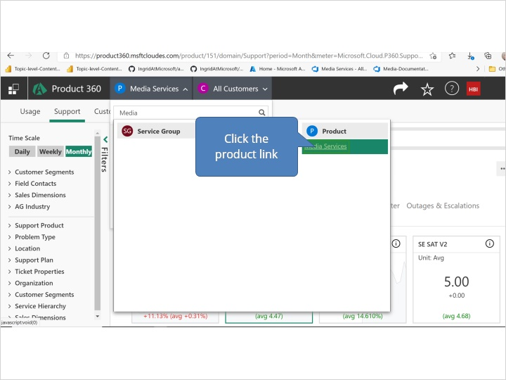

2.5 Click the group
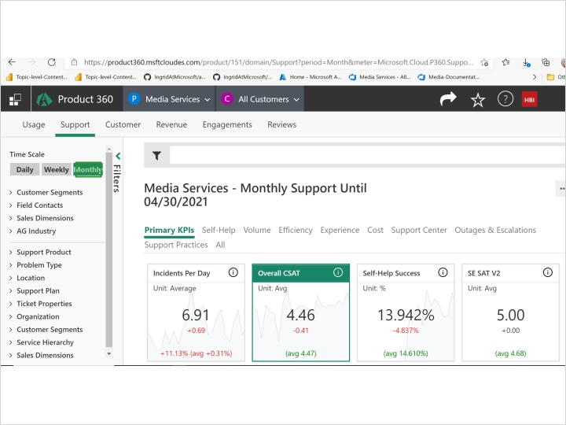

Rectangular Hotspot 1 (Slide Layer)
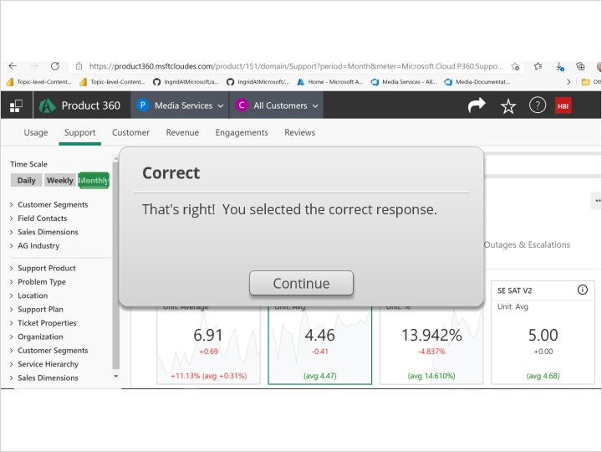

Try Again (Slide Layer)
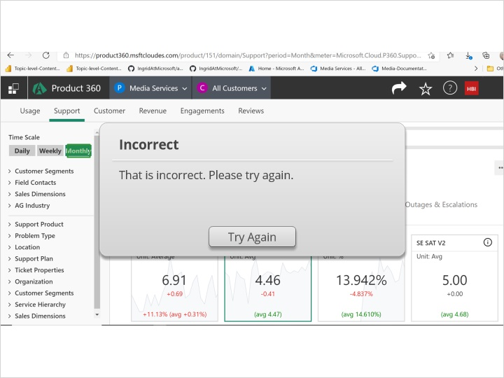

Hint Caption (Slide Layer)
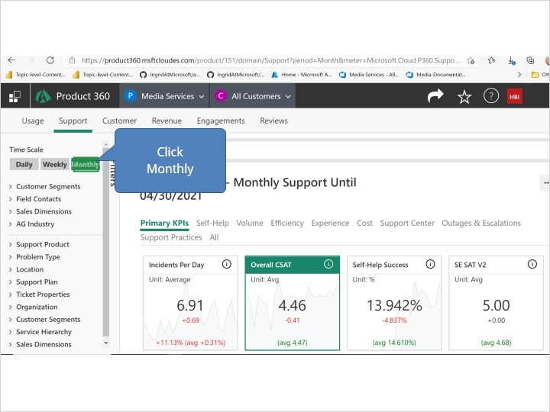

2.6 Click the Self-Help label
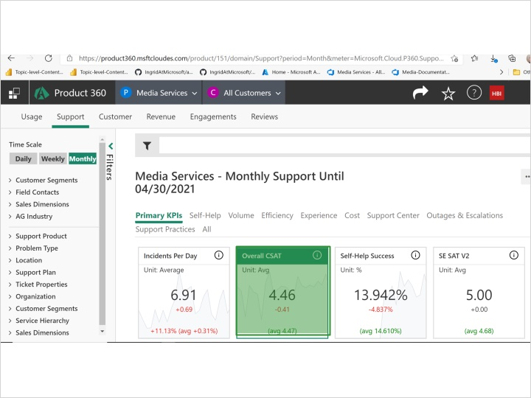

Rectangular Hotspot 1 (Slide Layer)
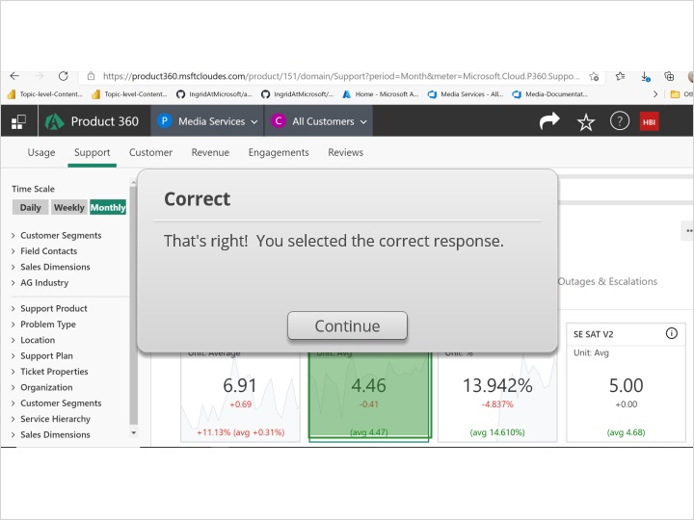

Try Again (Slide Layer)
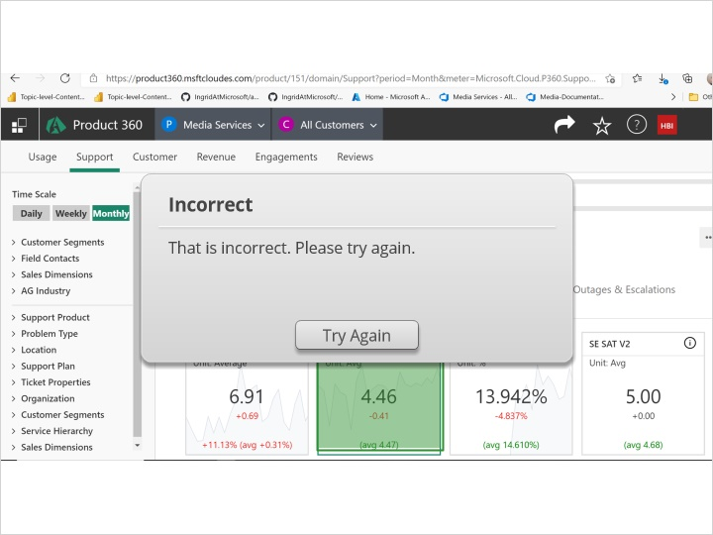

Hint Caption (Slide Layer)
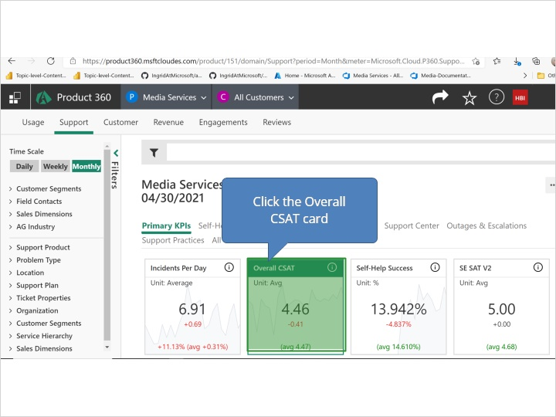

2.7 Scroll the mouse wheel
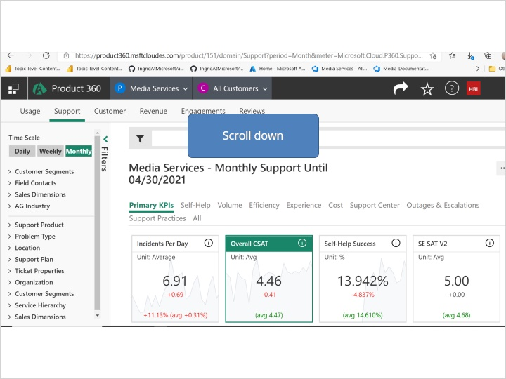

2.8 Click the Overall CSAT (Avg) - Monthly Support pane
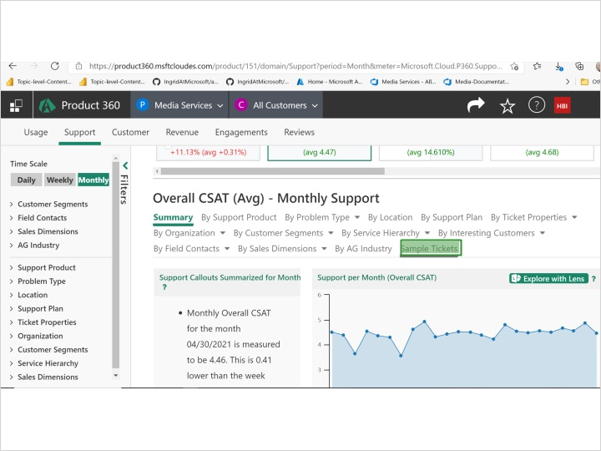

Rectangular Hotspot 1 (Slide Layer)
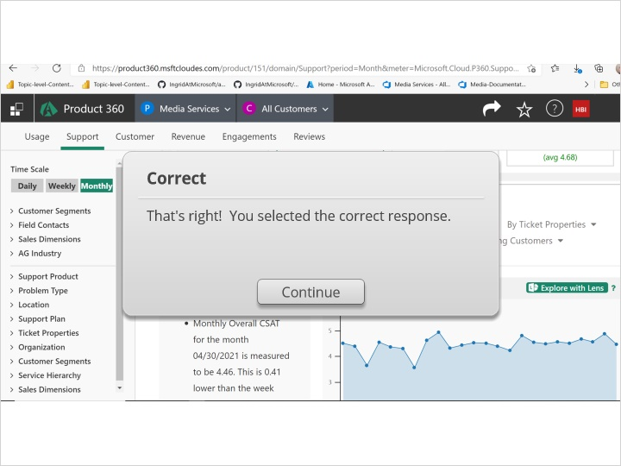

Try Again (Slide Layer)
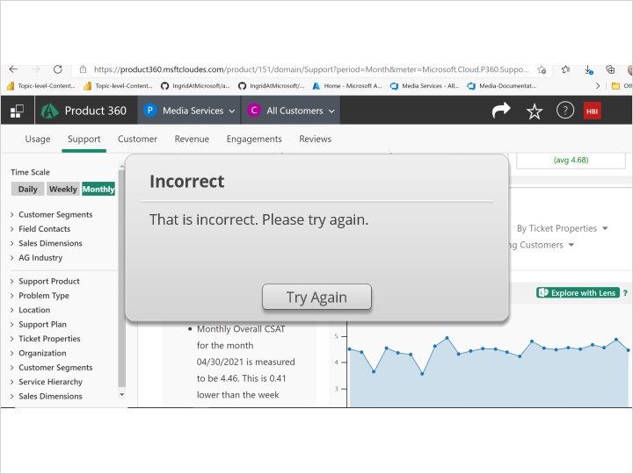

Hint Caption (Slide Layer)
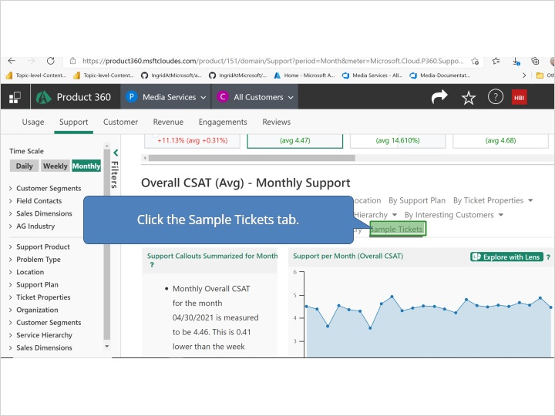

2.9 Click the Sample Tickets tab page
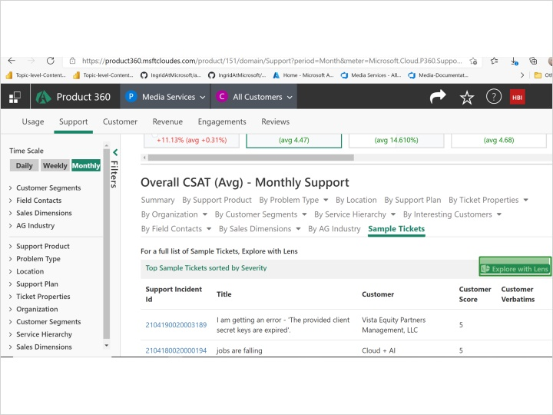

Rectangular Hotspot 1 (Slide Layer)
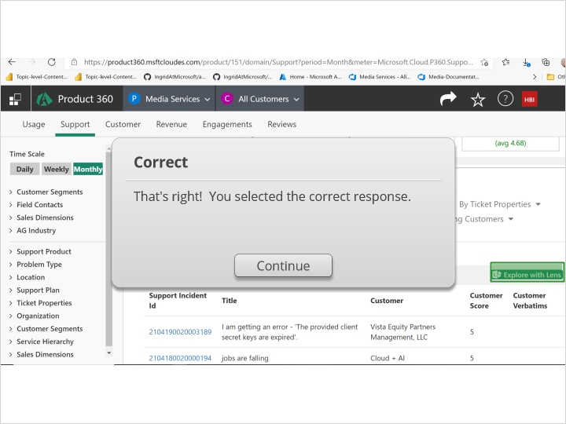

Try Again (Slide Layer)
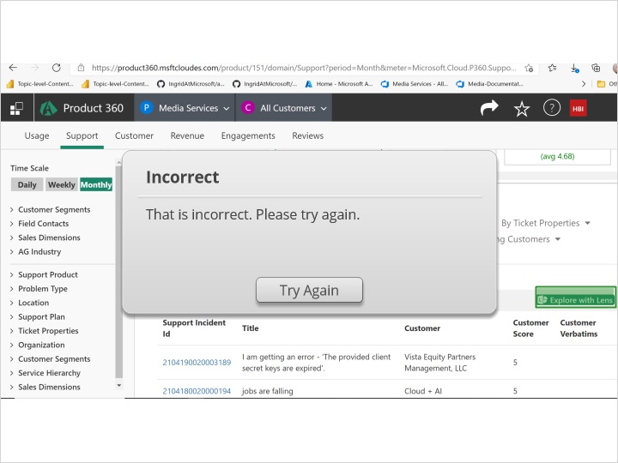

Hint Caption (Slide Layer)
